STUDENT NAME: Mogammad Mas'ood Lamera

Student number: 221376321

Multimedia Applications Foundation – Assignment 1

I am writing to discuss how I applied the UI/UX design laws to my solution. As you may know, UI/UX design plays a crucial role in creating a product that is not only visually appealing but also easy to use and navigate for the end-users.

When designing my solution, I made sure to incorporate the following UI/UX design laws:

1. Hick's Law - I kept the interface simple and easy to navigate, with minimal options to reduce decision-making time and improve the user experience.

E.g.

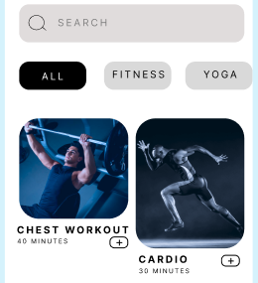

1. Fitts's Law - I designed the buttons and clickable elements in such a way that they were large enough and located at the lower parts of the screen which make them easy to click and reduce the likelihood of errors.

E.g.

1. Jakob's Law - I designed the solution to be consistent with similar solutions in the market, ensuring that users would be familiar with the interface and reduce the learning curve.
2. Millers Law - I designed the solution to have as little options as possible. For example, on the ‘Personal Plan’ page, I displayed only 2 workouts to choose from to avoid overwhelming the user.

E.g.

1. Postel's Law – This law will guide me to check if data conforms to standards and treat that data with respect.

E.g.

1. Gestalts Principle – I have applied many points of this principle. Namely:

* Law of Proximity: Many related elements are close together. Ie, the GIFs on the ‘Recovery Program’ page and videos on the ‘Chest Workout’ page. Example on next page.

E.g.

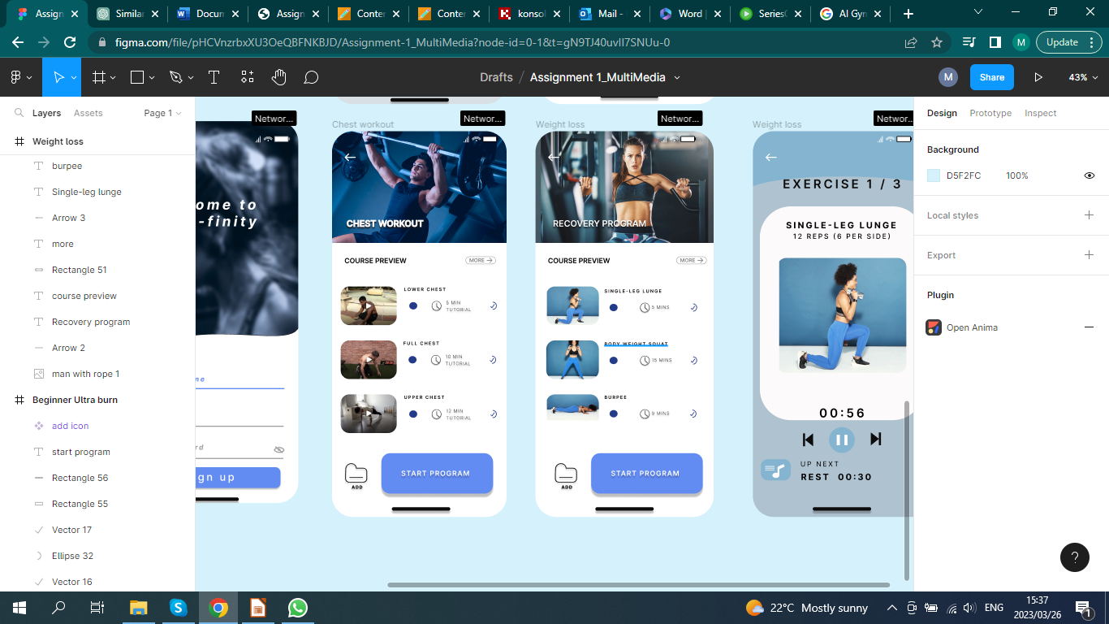

* Law of similarity: It states that similar objects are perceived as related or grouped. For example, I used a consistent color scheme and font style for all the related buttons.

E.g.

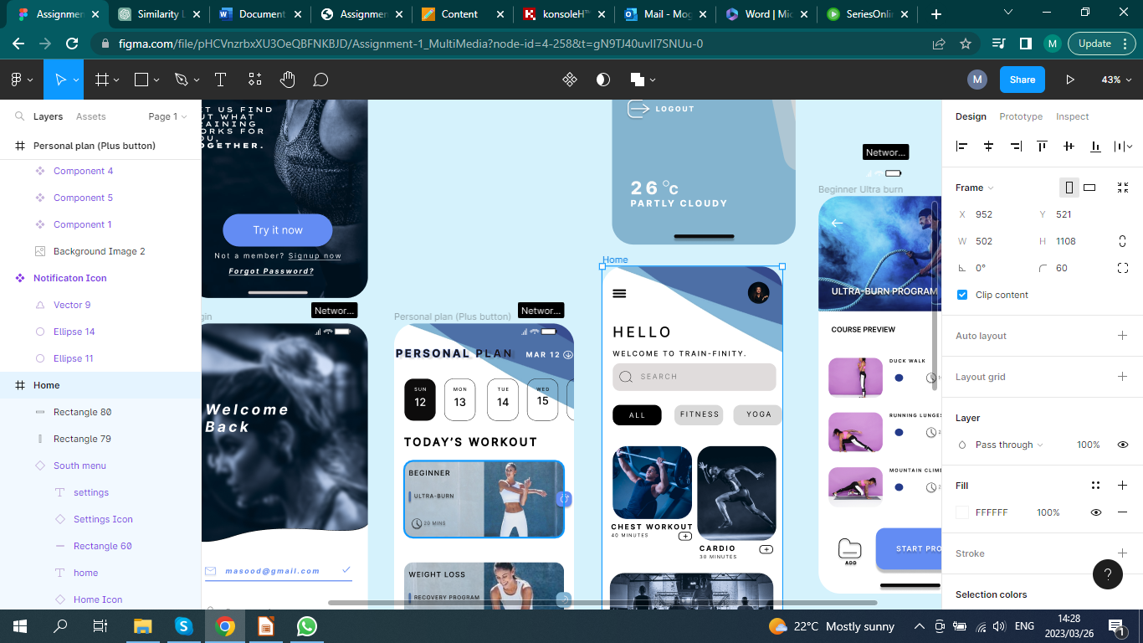

* Law of Continuity: Elements placed in a line, whether curved or not, are seen as a group. That said, the above example abides by this law too.

E.g.

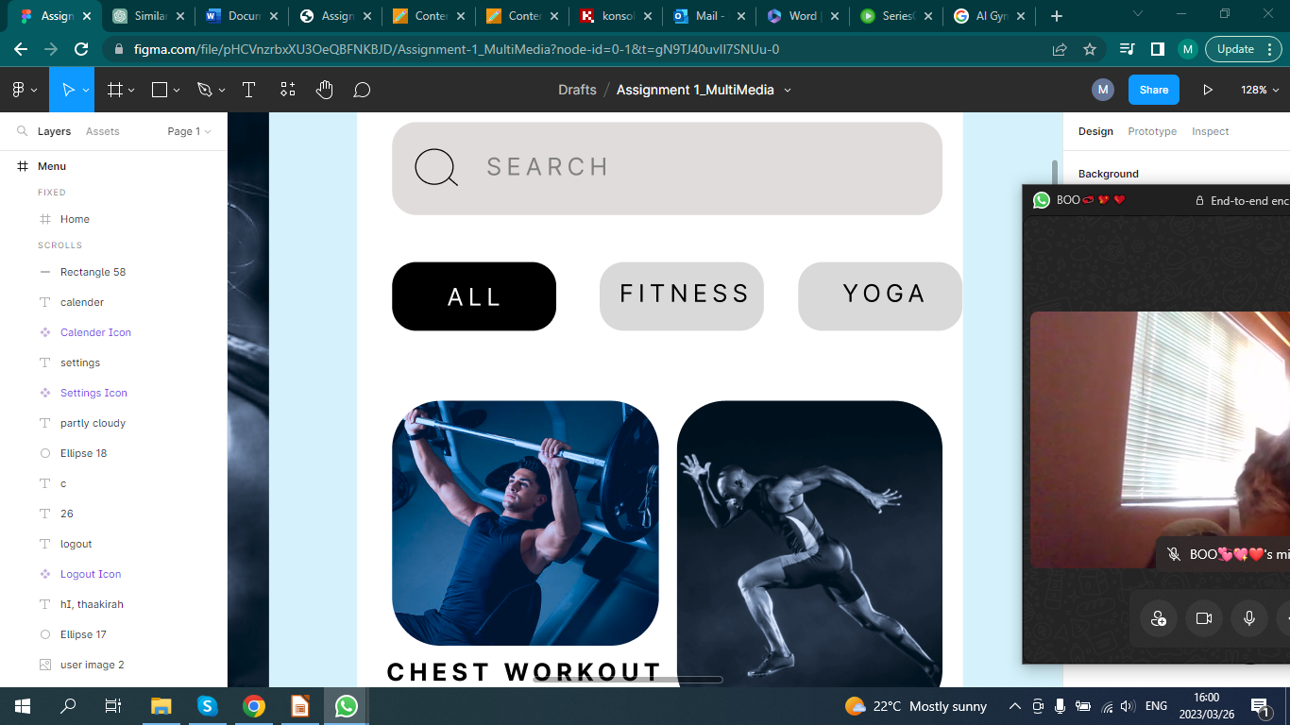

* Law of Common fate: If objects move together, they are perceived as a group. I followed this law and decided to make my South Menu part of this law. The icons shown in the example below never leave each other's side.

E.g.

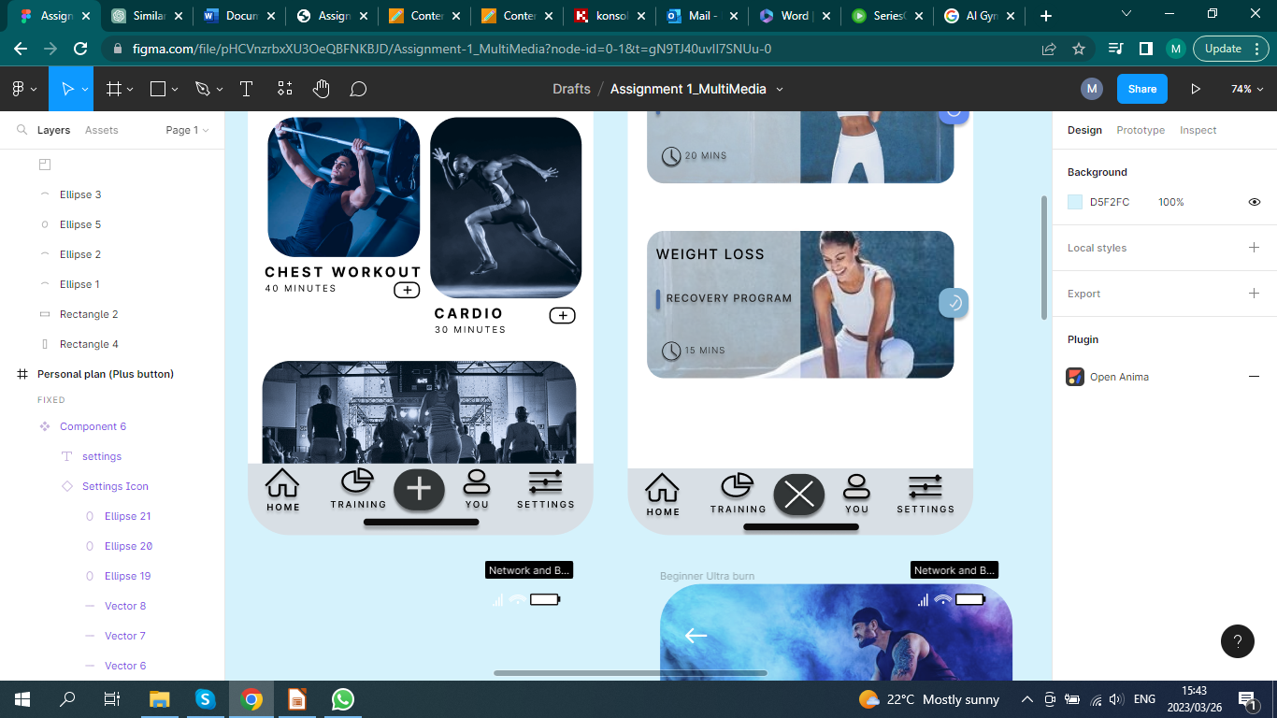

________________________________________________________________________

**Welcome to Train-Finity**

This application is designed to help you achieve your fitness goals by providing you with customized workout plans, tracking your progress, and offering a variety of exercises to keep you motivated and engaged. Whether you are a beginner or an experienced athlete, our app has something for everyone. With easy-to-follow instructions and helpful tips, you will be on your way to a healthier, fitter you in no time. So, let us get started and start reaching your fitness goals today!

1.

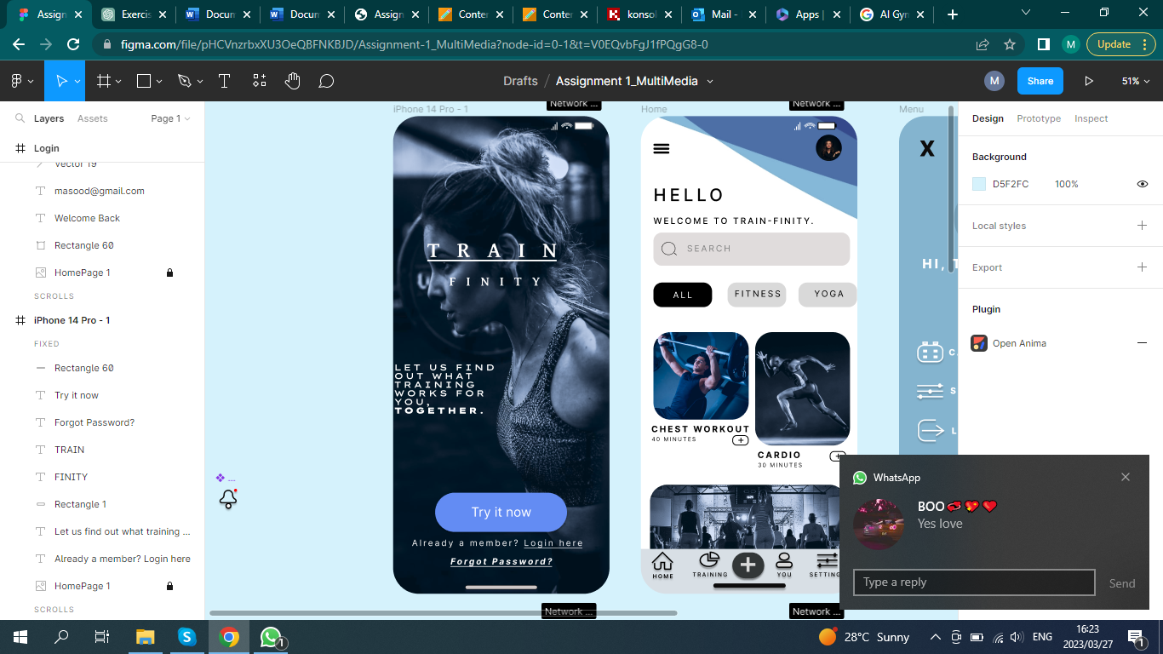

Click here if you would like join the Train-Finity team.

Click here if you would like to Log in to your Train-Finity account.

Click here if you have an account but forgot your password.

2a: Log in

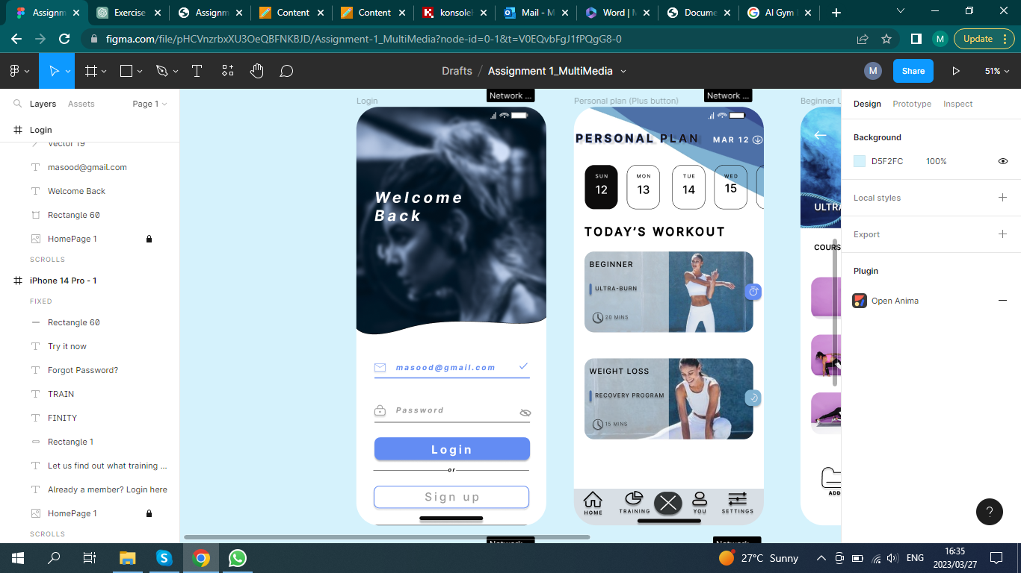

If you clicked on "Login here", this page would appear, prompting you to enter your login details.

Once you entered your details, you can Log in by clicking the 'Login' button.

If you accidentally clicked try it now, you can still access the Sign up page by clicking the "Sign up" button

2b: Sign up

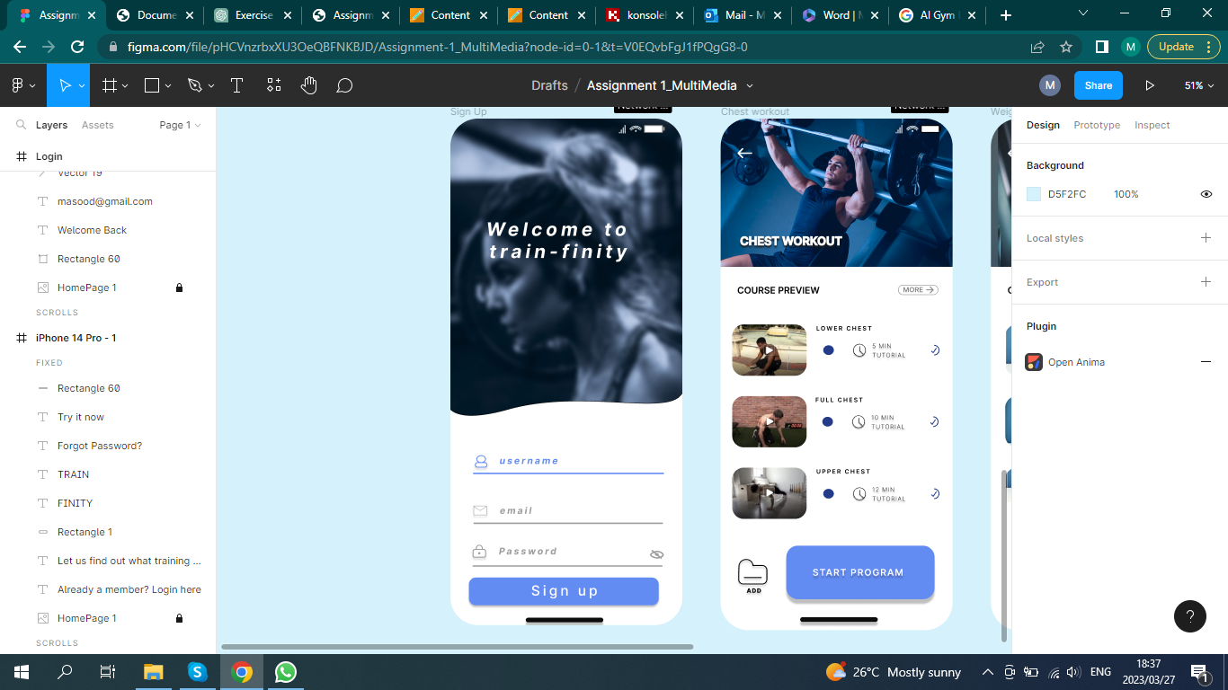

If you clicked "Try it now", This page would show. You can register and become a member.

You should enter a Username, your email and a password in order to Sign up.

Once all of the information has been provided, you can click on the "Sign up" button to register.

3: Home

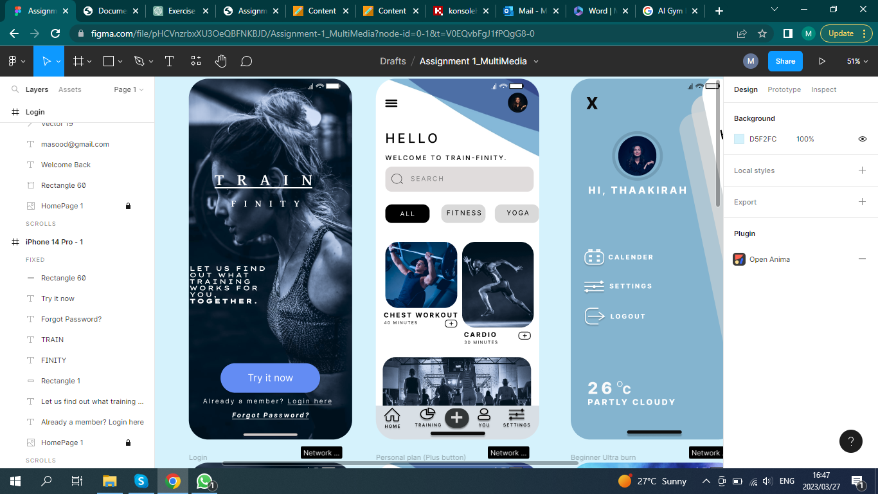

Once logged in, you will be redirected to the Home Page.

Here you can search for any type of workout.

You can choose from the suggested type of workouts.

You can click on either of these to go straight into the course.

This navigation bar has 5 buttons:

1)Home: takes you to t he start of the pagecount.

2)Training: takes you to your most recent exercise.

3) Add: takes you to your personal plan.

4) You: Takes you to your accunt

5) Settings: Takes you to your settings.

This Burger Icon would take you to the menu

3.1: Menu

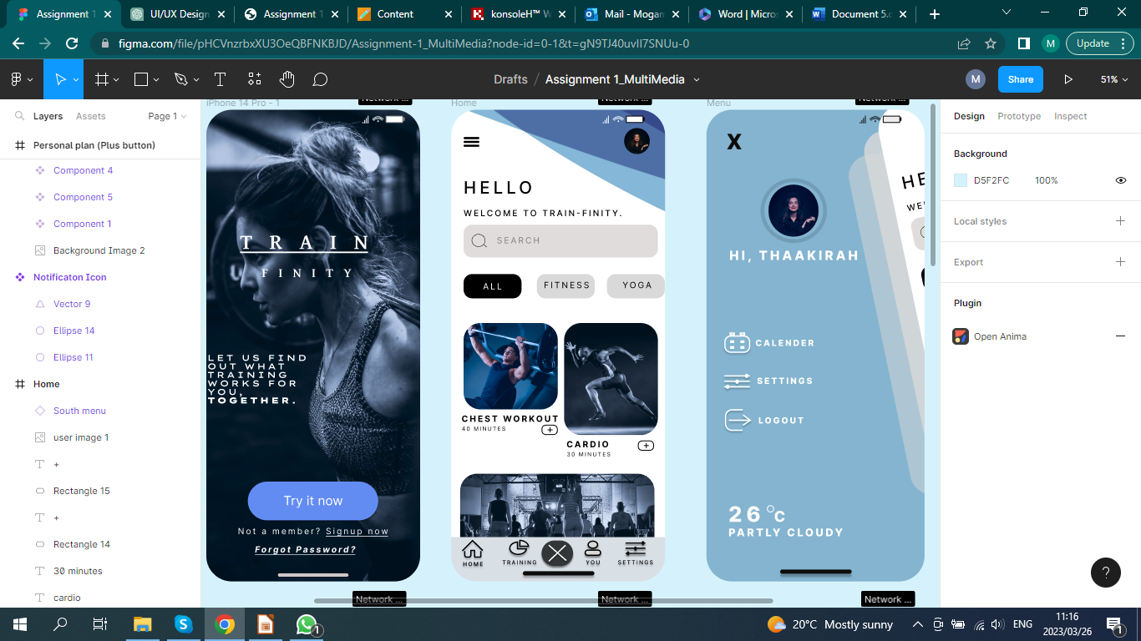

When you click the menu button, this page would appear.

You can check your calender, which in turn would be your Personal Plan.

You can access the applications settings through here:

You can log out by clicking the "Logout" button.

3.2 a: Personal Plan (Add (+) button)

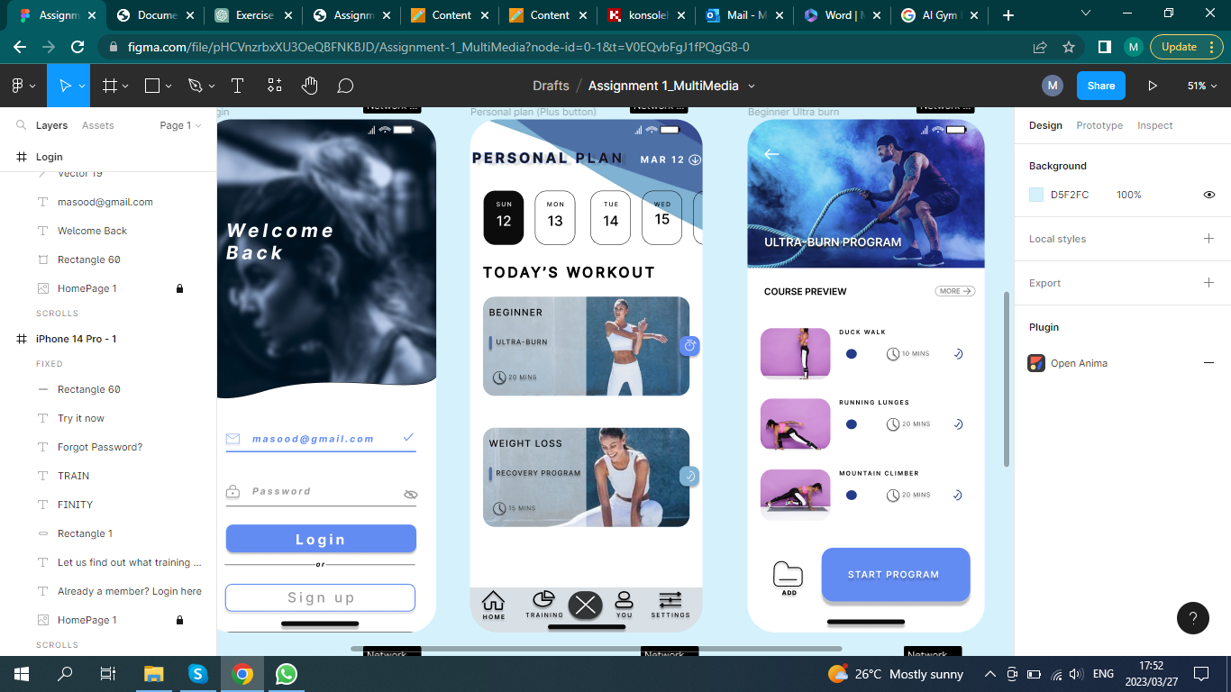

When you click on the Add button ( + ), you would be directed to this page, which is the "Personal Plan" page.

These two are workout options for the day. you can choose either to do.

3.2 b: Recovery Program

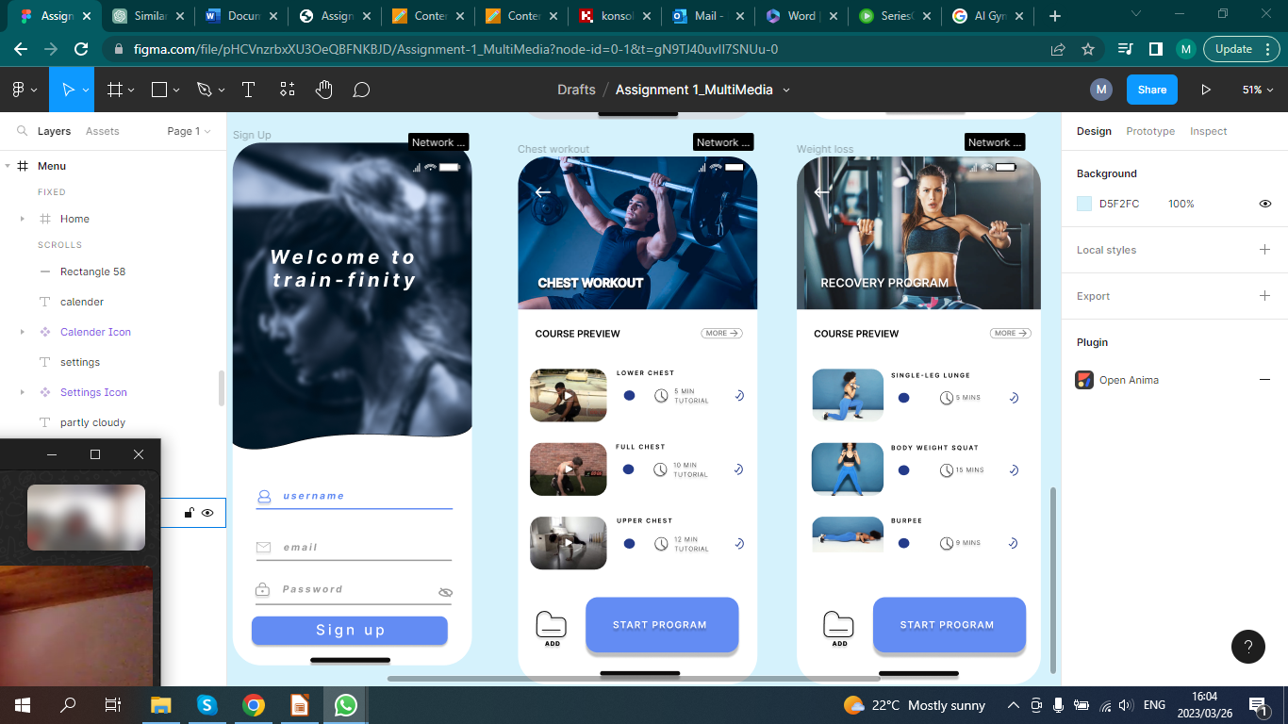

If you clicked on the "Weight Loss: Recovery Program" tab, this page would appear

These 3 Images are GIF's. It would guide you in completing the prescribed exercise

This button would add the workout to your Personal Plan.

If you decided to do the suggested workouts, you can click on the "Start Program" button.

3.2 c: Started the Program

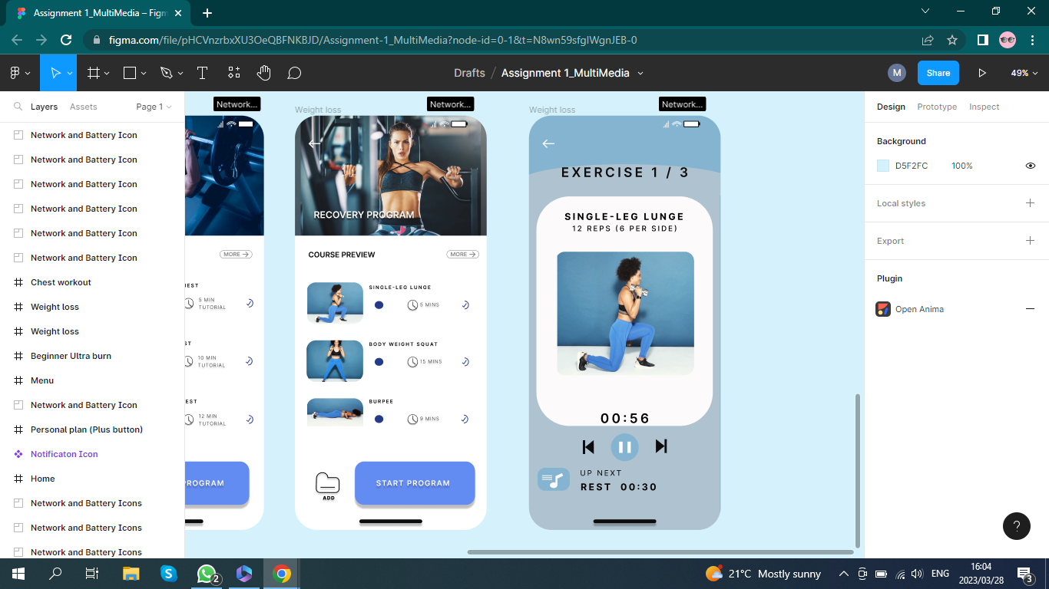

This shows which exercise you are currently doing.

This GIF demonstrates to you how the exercise should be done.

This is the name of the exercise and the amount of times you should do the movement.

If you clicked "Start Program", this page would appear.

This allows you to either return to the previous exercise, pause the current one or skip to the next exercise.

This displays the amount of time left for you to do the exercise.

This shows you what appears once the time depletes.

3.3 a: Chest Workout



If you chose the "Chest Workout" tab, this page will appear.

The layout is exactly the same to the previous page (Weight loss). Instead of GIFs, this page consists of videos which could guide you visually and audibly.

3.3 b: Start Program

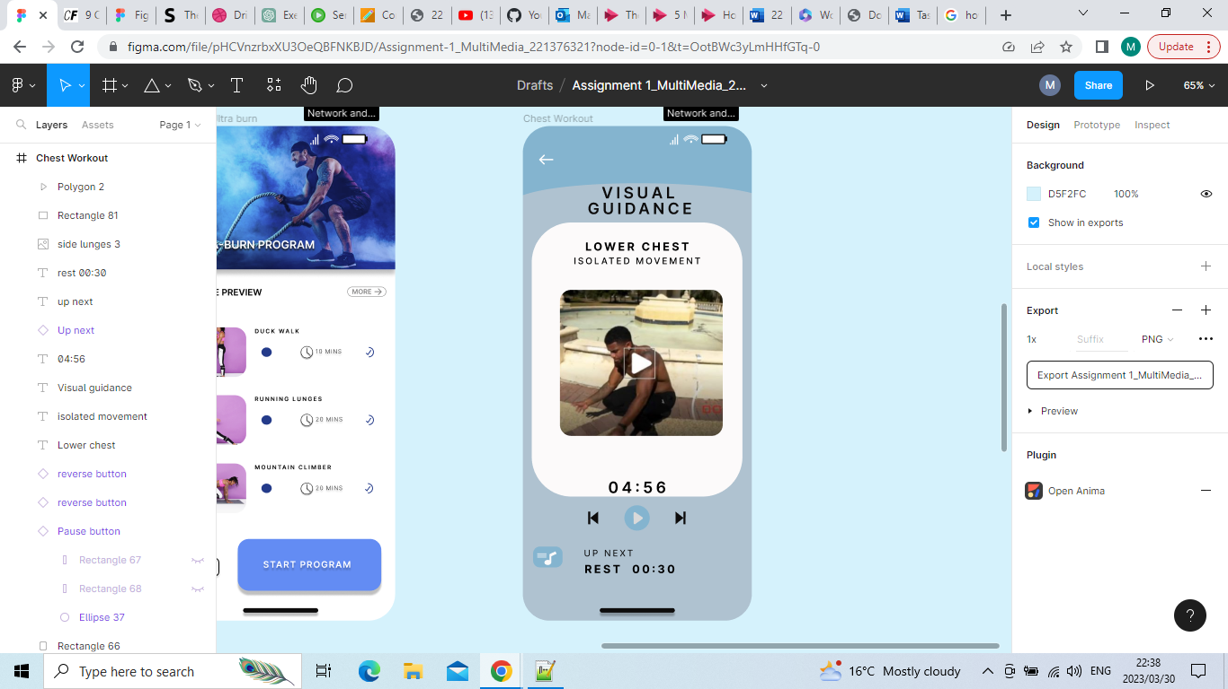

This is the Visual Guidance page. It includes a visual and audio presentation on how to do the chosen exercise. By incorporating audio, the user can significantly enhance their understanding and derive greater benefit from this video.

In conclusion, this application design offers a user-friendly and engaging way for individuals to receive guidance on various exercises through multimedia elements. The incorporation of videos, images, and audio instructions provides users with clear and concise guidance, making it easy to follow along with each exercise. The design of the application also allows for personalization, as users can select the type of exercise, duration, and difficulty level that best suits their needs. Overall, this application design is an effective tool for individuals who seek to improve their physical health through regular exercise, and the use of multimedia elements adds an interactive and immersive dimension to the user experience.